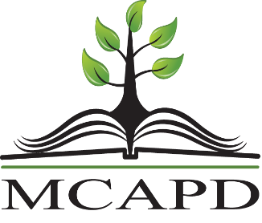
19TH ANNUAL MCAPD ADJUNCT CONFERENCE

Human-Centered Teaching in a Time of Accelerated Change
SUBMIT PROPOSALS HERE: DUE MAY 31, 2026
CCBC Owings Mills campus I 10300 Grand Central Ave, Owings Mills, MD 21117
Saturday, October 10, 2026 I 8:30 AM—3:30 PM

2026 Workshop Themes
Responsible use of AI in teaching and learning
Explores ethical, transparent, and pedagogically sound ways to use AI tools that support, not replace, human judgment and instructional integrity

Innovations in teaching
Showcases creative, evidence informed teaching strategies and new approaches that enhance engagement, flexibility, and learning outcomes.

Building community in the classroom
Highlights practices that foster belonging and collaboration among diverse learners in both physical and virtual environments.
Supporting learner success
Focuses on approaches that remove barriers, promote equity, and strengthen academic and personal success for all students.

Promoting faculty resilience
Highlights strategies that help faculty adapt to change and strengthen their capacity to navigate evolving teaching environments with confidence and purpose.

AI tools may be used to assist in drafting proposals; however, all submissions must present accurate information grounded in evidence, established practice, or original experience. Presenters are responsible for verifying the accuracy of all content

REGISTRATION LINK
Designed for connection: limited to 100 participants. We anticipate strong interest and recommend registering early.

